

**Science Knowledge Organiser**

Year 6

Light

Summary Statement

We need light in order to see. Light travels from a light source - in a straight line - reflects off objects and into our eyes. If light is blocked then a shadow is made. Shadows are the absence of light.

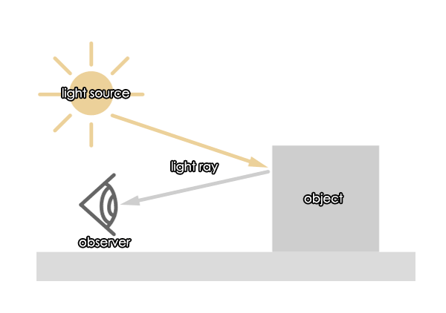

**By the end of the unit children can:**

●recognise that light appears to travel in straight lines

● use the idea that light travels in straight lines to explain that objects are seen because they give out or reflect light into the eye

● explain that we see things because light travels from light sources to our eyes or from light sources to objects and then to our eyes

● use the idea that light travels in straight lines to explain why shadows have the same shape as the objects that cast them.

|  |  |
| --- | --- |
| **Key Vocabulary** | |
| **Spelling** | **Definition** |
| beam | A ray of light |
| opaque | Opaque materials do not allow light rays to pass through them. An example is wood. |
| translucent | Translucent materials allow some light rays to pass through them. We cannot see through them clearly. An example is frosted glass. |
| transparent | Transparent materials allow light rays to pass through them easily. An example is clear glass. |
| reflection | When light from an object is reflected by a surface, it changes direction. |
| inverted | When an image appears back to front when looked at in a mirror. |

|  |
| --- |
| **Key Knowledge** |
| Light is a type of energy that makes it possible for us to see the world around us.  We need light to see. Light comes from different sources called light sources; our main natural light source is the sun. Other sources include fire, stars and man-made light sources such as light bulbs and torches.  Light travels in straight lines from a light source and reflects off an object and into our eyes.  Shadows  The shape of a shadow is defined by the shape of the object causing it. If you move the object creating a shadow towards the light source, the shadow gets bigger. If you move the object towards the screen then the shadow gets smaller.  mage result for how shadows are formed |