

**Science Knowledge Organiser**

Year 6

Animals including humans: Health

**Summary Statement**

**It is important to keep our bodies healthy by exercising regularly and eating a balanced diet.**

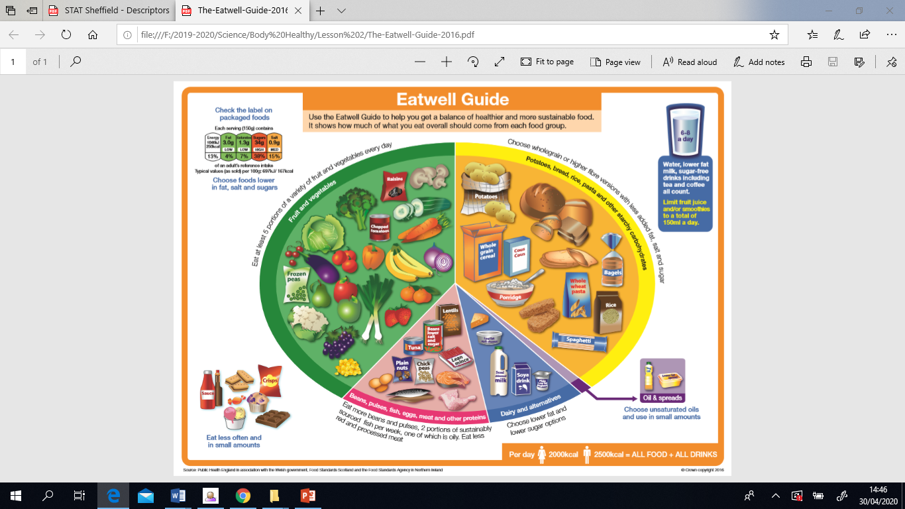

**By the end of the unit children can:**

Recognise the impact of diet, exercise, drugs and lifestyle on the way their bodies function.

|  |
| --- |
| **Key Knowledge** |
| **Diet**:  We need to eat a balanced diet to keep our bodies healthy.  Different food groups are required for different reasons:   * **Carbohydrates**: main energy source * **Proteins**: help to build and repair our bodies * **Fruit** **and vegetables**: contain vitamins and minerals * **Fats**: contains fatty acids to help absorb vitamins   Your pulse tells you how fast your heart is pumping.  **Exercise**:  We need to look after our bodies and keep them healthy. We can do this by exercising regularly, which makes us stronger and more efficient.    **Drugs:**  Drinking alcohol, smoking tobacco and taking certain drugs can have a negative impact on our bodies and have both short and long effects.  Medicine is a type of drug and they can be helpful and aid our recovery from illness. |

|  |  |
| --- | --- |
| **Key Vocabulary** | |
| **Spelling** | **Definition** |
| carbohydrates | a substance that is rich in energy |
| protein | an essential nutrient to build cells |
| vitamins & minerals | nutrients that humans need in order to grow and be healthy |
| drugs | a chemical that is not food that affects your body |
| obesity | having too much fat |
| pulse rate | the number of times your heart beats in a minute |