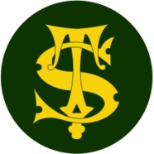
Science Knowledge Organiser
Year 6
Living things and their habitats: classification
Summary Statement
Plants and animals can be divided into groups or 'classified' by looking at the similarities and differences between them.

Key Vocabulary
Spelling | Definition
Vertebrates | Animals with a backbone
Invertebrates | Animals without a back bone
Arachnids | 2 body sections/8 legs
Molluscs | Slimy foot/ often have a shell
Distinguish | Recognise a difference.
Micro-organisms | An organism that microscopic
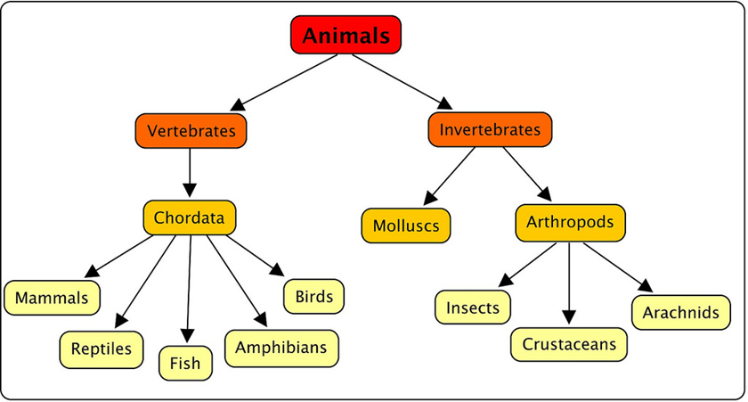
By the end of the unit children can:
- Describe how living things are classified into broad groups according to common observable characteristics and based on similarities and differences, including micro-organisms, plants and animals
- Give reasons for classifying plants and animals based on specific characteristics.
Key Knowledge
- Carl Linnaeus developed the first system to classify animals effectively by grouping them based on their characteristics.
- Animals can be put into one of two groups: vertebrates and invertebrates.
- There are 5 vertebrate groups:
- Mammals
- Reptiles
- Fish
- Amphibians
- Birds
(MR FAB)
- Invertebrates are animals without backbones. The main groups are:
- Insects
- Arachnids
- Molluscs

- Key Features to distinguish between plants
- Flowering or Non-Flowering
- Grass/cereal/garden shrub/deciduous/ algae/coniferous/fern
- Colour
- Height
- Number of flowers
- Fruit bearing or not
- Distinguishing features
- Usual location

- Micro-organisms are the other main group of living things, e.g. fungi, bacteria

