
Science Knowledge Organiser
Year 2
Plants: The Apprentice Gardener
Summary Statement:
Pupils recap what plants need to grow healthily and the differences between bulbs and seeds. This unit includes an investigation about growing healthy plants.

By the end of the unit children can:
- Observe and describe how seeds and bulbs grow into mature plants.
- Find out and describe how plants need water, light and a suitable temperature to grow and stay healthy.

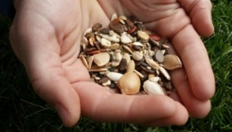
bulbs
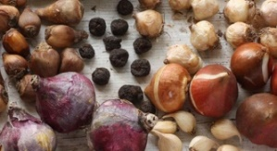
seeds

Key Vocabulary
Spelling | Definition
Life Cycle | A series of changes living things go through.
Seed | The part of the plant from which new plants grow.
Bulb | Part of a plant under the dirt that stores food while the plant is resting from growing.
Mature plant | A plant that is fully grown or has been growing for a long time.
Observations | Seeing and taking notice of something.
Germination | When the seed begins to grow.
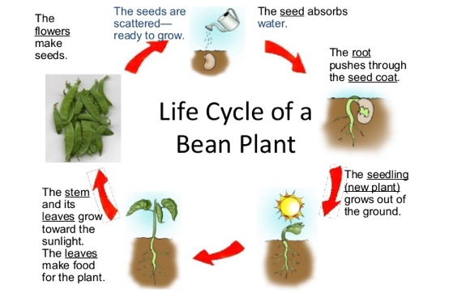

Key Knowledge
All plants go through a life cycle. A circle diagram is used to show that it is a continuous process.
Seeds need the following to germinate:  - Water  - Oxygen  - Warmth | Plants needs the following to grow and be healthy (LAWNS):  - Light  - Air  - Water  - Nutrients (‘food’ absorbed by the roots)  - Space
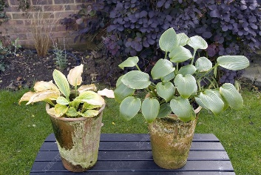
Healthy plants are green and strong but unhealthy plants are often pale, yellowy and weak.

Plants grow from seeds and bulbs. Seeds are sown and bulbs are planted. They both have a store of food inside them.
Germination stages: seed is planted absorbs water and starts to grow roots and shoots grow stem and leaves grow some may grow flowers and seeds seeds are spread by animals, humans and wind and the process starts again.
Roots always grow downwards to find more water. Shoots grow upwards to find light.

