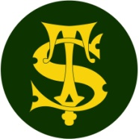

**Science Knowledge Organiser**

**Year 2**

**What’s in your Habitat? Living Things and their Habitats: Food Chains**

Summary Statement

All living things have certain characteristics that are essential for keeping them alive and healthy. Most living things live in habitats that provide them with food, water and shelter and allow them to reproduce.

A Simple Food Chain

**By the end of the unit children can:**

- Describe how animals obtain their food from plants and other animals, using the idea of a simple food chain, and identify and name different sources of food.

hawk

blackbird

caterpillar

leaf

|  |
| --- |
| **Key Knowledge** |
| * The arrow in a **food chain** means ‘is eaten by’. |
| * In a healthy **habitat**, all living things depend on each other and each part of the chain is food for another. |
| * Plants are producers and can make their own food using sunlight. |

seal

fish

algae

Example of a polar food chain:

polar bear

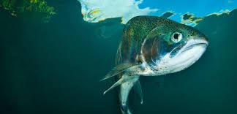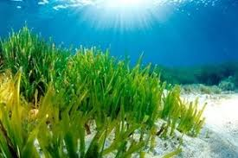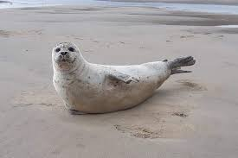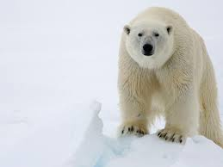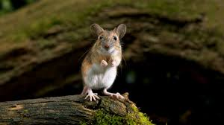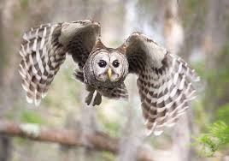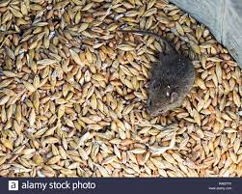

nuts

owl

mouse

|  |  |
| --- | --- |
| **Key Vocabulary** | |
| **Spelling** | **Definition** |
| Food Chain | A group of living things each dependent on the other as a source of food. |
| Producer | Green plants at the start of most food chains. They are called producers because they produce (make) their own food. |
| Consumer | The animals that consume (eat) plants and other animals. |
| Source of food | The start of a food chain e.g. green plants |
| Predator | An animal that lives mostly by killing and eating other animals. |
| Prey | An animal being hunted, caught and eaten by another animal. |