

**Science Knowledge Organiser**

**Year 2**

**Living Things and their Habitats: Dead or Alive?**

Summary Statement

All living things have certain characteristics that are essential for keeping them alive and healthy. Most living things live in habitats that provide them with food, water and shelter and allow them to reproduce.

Examples of alive, never alive and dead

Examples of Habitats

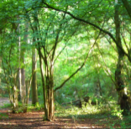

**By the end of the unit children can:**

* Explore and compare the differences between things that are living, dead, and things that have never been alive.
* Identify that most living things live in habitats to which they are suited and describe how different habitats provide for the basic needs of different kinds of animals and plants, and how they depend on each other.
* Identify and name a variety of plants and animals in their habitats, including microhabitats.

Forests and woodlands are places where there are mostly trees. They can be hot or cold. This habitat is home to deer, rabbits, bears and owls.

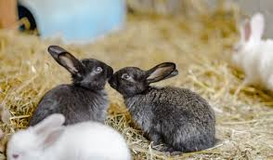

Alive

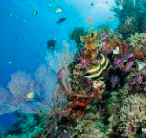

Oceans and seas contain salt water. This habitat is home to fish, shark and octopus.

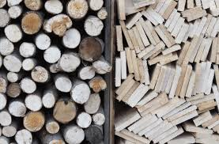

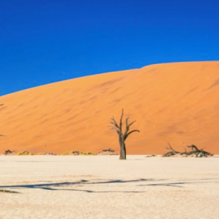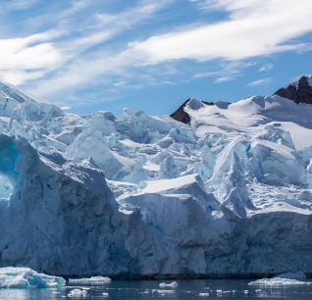

Dead

**Desserts are places that don’t get much rain and are very dry. They can be hot or cold. This habitat is home to scorpions, antelope and lizards.**

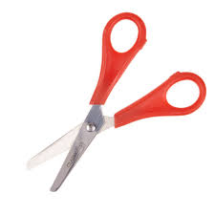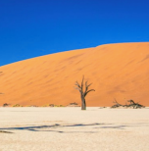

Never alive

|  |
| --- |
| **Key Knowledge** |
| * We can use the anagram **‘Mrs Gren’** to help us identify if things are alive or not. All living things share the following characteristics: * **M**ove- all living things move.   **R**eproduce- have babies.  **S**ensitive- can sense and adapt (change) to suit their surroundings.  **G**rowth- all living things grow.  **R**espire- release energy from food.  **E**xcretion- get rid of waste.  **N**utrition- take in nutrients/food. |
| * Some things may have ‘once lived’ but have since died e.g. a plant, animals or dead skin. We usually refer to these things as being dead but the correct scientific term is ‘once lived’. |
| * Other things like rocks, soil, air and plastic have never lived. |
| * Most living things live in habitats to which they are suited and can provide them with the food, shelter, water and space that they need. For example, a shark is suited to its habitat (ocean) because it has fins to help it swim through the water, it has gills to help it breath under water and it also has accesses to lots of sea life for food. |

|  |  |
| --- | --- |
| **Key Vocabulary** | |
| **Spelling** | **Definition** |
| Habitat | A home for animals, plants and any living thing. |
| Microhabitat | A small home for plants, animals and insects. For example under a stone for woodlouse. |
| Adapted | Characteristics/traits that help animals survive in their surroundings. |
| Shelter | What animals use to protect themselves from their surroundings e.g. weather and predators. |
| Once-lived | Objects that used to be alive but now are not e.g. wood made into a table. |
| Never-alive | Objects that never needed to do any of the characteristics from MRS GREN |
| Decay | To break down slowly by natural processes. |