

**Science Knowledge Organiser**

**Year 1**

**Plant Detectives**

Summary Statement:

Plants, including trees, are living things. There are many varieties of garden and wild plants and they come in many different shapes and sizes.

**By the end of the unit children can:**

* Identify and name a variety of common wild and garden plants, including deciduous and evergreen trees.
* Identify and describe the basic structure of a variety of common flowering plants, including trees.

|  |  |
| --- | --- |
| **Key Vocabulary** | |
| **Spelling** | **Definition** |
| Evergreen | A plant or tree that keeps its leaves all year. |
| Deciduous | A tree that loses its leaves in autumn and grows new ones in spring. |
| Roots | Hold the plant in the ground and collects water and nutrients from the soil to help the plant grow. |
| Stem | Holds the flower and leaves up high and transports water. |
| Flower | Creates seeds |
| Trunk | The stem of a tree from which its branches grow. |
| Branch | The part of a tree that grows out from the trunk. |
| Seeds | The part of a plant from which new plants grow. |
| Leaves | Collect energy from the sun to help the plant grow. |

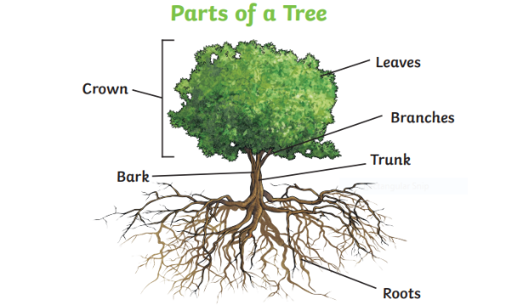Key Knowledge:

|  |  |  |  |
| --- | --- | --- | --- |
| Examples of  **deciduous trees**: | C:\Users\Clifford.J\Local Settings\Temporary Internet Files\Content.Word\IMG_2843.JPGSycamore | C:\Users\Clifford.J\Local Settings\Temporary Internet Files\Content.Word\IMG_2842.JPGSticky Maple | C:\Users\Clifford.J\Local Settings\Temporary Internet Files\Content.Word\IMG_2841.JPG  Beech |
| Examples of  **evergreen trees:** | Holly | Italian Cypress Tree Conifer Wilma Outdoor Garden Plant Easy to Grow  Evergreen 2 x Cupressus Plants in 10.5cm Pots by Thompson & Morgan :  Amazon.co.uk: Garden  Conifer | Yew |
| Examples of  **garden plants**: | Pansy | Rose | Lavender |
| Examples of  **wild plants:** | Buttercup | Daisy | Dandelion |

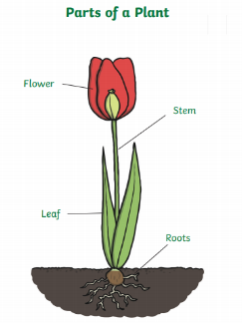



**Did you know..?**

The UK’s oldest tree, thought to be in Scotland, is estimated to be around 3000 years old!