

Summary Statement:

All animals have things in common which help us to group them. For example, humans are mammals and omnivores.

**Science Knowledge Organiser**

**Year 1**

**Animals including humans**

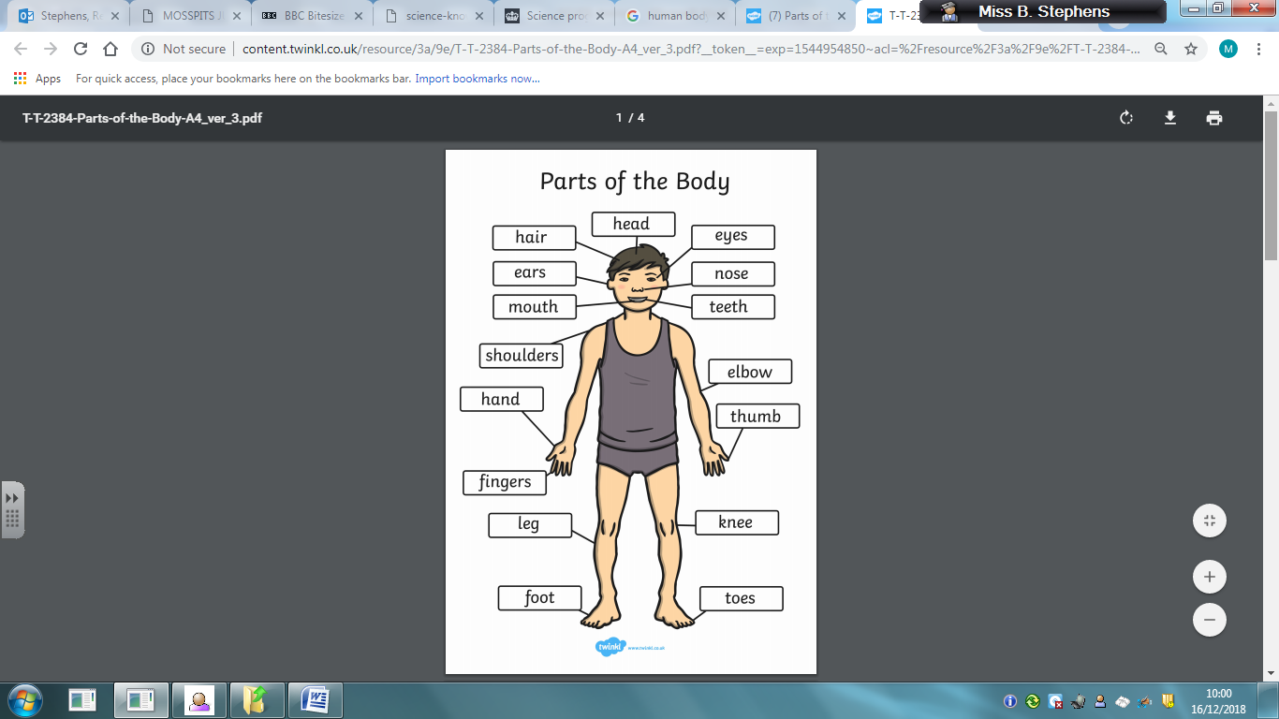

**By the end of the unit children can:**

* Identify and name a variety of common animals including fish, amphibians, reptiles, birds and mammals.
* Describe and compare the structure of a variety of common animals.
* Identify and name a variety of common animals that are carnivores, herbivores and omnivores.
* Identify, name, draw and label the basic parts of the human body and say which part of the body is associated with each sense.

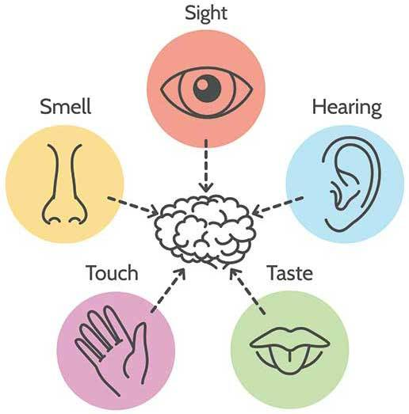

|  |  |  |
| --- | --- | --- |
| **Key Knowledge**  Animals are grouped together based on their shared features. There are **5** main animal groups. | | |
| **Type of animal** | **Features** | **Common examples** |
| **C:\Users\stephens.b\Local Settings\Temporary Internet Files\Content.IE5\HGPS02LR\Cow-IMG_2050[1].jpgMammals** | - Have hair or fur.  -Give birth to live young.  -Produce (make) milk for their babies. | human  dog  lion |
| **C:\Users\stephens.b\Local Settings\Temporary Internet Files\Content.IE5\EVA5DD01\Fish_-_Puntius_sarana_from_Kerala_(India)[1].pngFish** | -Live in water  -Have fins, scales and gills. | goldfish  cod  shark |
| **C:\Users\stephens.b\Local Settings\Temporary Internet Files\Content.IE5\KHC7PTRU\chicken[1].jpgBirds** | -Have feathers, wings and a beak.  - Lay eggs  -Usually able to fly. | chicken  owl  robin |
| **Reptiles**  **C:\Users\stephens.b\Local Settings\Temporary Internet Files\Content.IE5\KHC7PTRU\Joshua_Tree_NP_-_Desert_Side-blotched_Lizard_-_1[1].jpg** | -Lay eggs.  - Dry, scaly skin. | snake  crocodile  lizard |
| **Amphibians**  C:\Users\stephens.b\Local Settings\Temporary Internet Files\Content.IE5\YS67WFB4\White_lipped_tree_frog_cairns_Jan_8_2006b[1].jpg | -Live on land or in water.  -Lay eggs in water. | frog  toad  newt |

|  |  |
| --- | --- |
| **Key Vocabulary** | |
| **Spelling** | **Definition** |
| Carnivores | Animals that eat meat (other animals)  e.g., lion, tiger and bear. |
| Omnivores | Animals that eat meat and plants e.g., human, pig, rat. |
| Herbivores | Animals that eat plants e.g., cow, sheep, rabbit. |
| Pets | Friendly animals trained to live with humans e.g., cat, dog, rabbit. |
| Nocturnal animals | An animal that sleeps during the day and is active at night e.g. a bat. |

Did you know ..?

Bats are flying mammals. While others can glide, bats are the only mammals capable of continued flight.

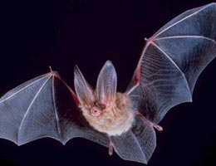

**Did you know..?**

A spider’s web is the strongest *natural* material ever known! It is ten times stronger than steel (a type of metal alloy).