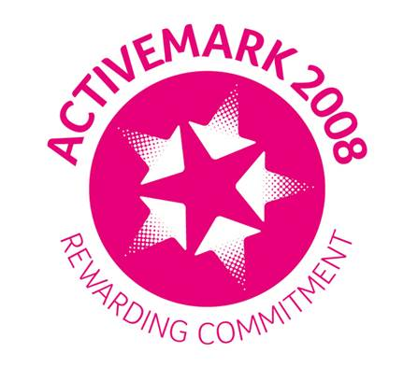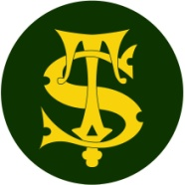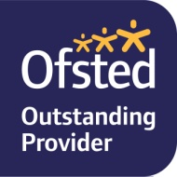

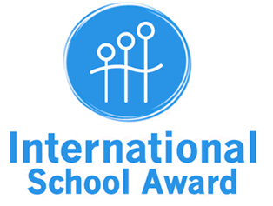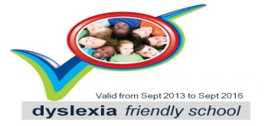**Investors in People Logo**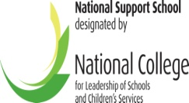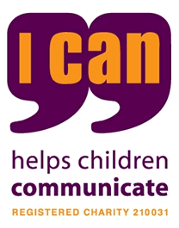

Dear Parents and Carers,

This letter has been written to give you further information about how schools will respond if they find that a pupil has symptoms of Coronavirus (Covid-19) in schools. It also tells you what you should do as parents or carers in this situation.

**How Schools will respond to symptoms of Coronavirus (COVID-19) from September 2020**

As you know, it is the government’s plan that all children should attend school from September 2020 and everyone at our school is delighted to welcome back all our pupils. The government has produced information for parents which you can read by following the link at the end of this letter.

The scientific evidence shows that coronavirus (COVID-19) presents a much lower risk to children than adults of becoming severely ill, and there is no evidence that children transmit the disease any more than adults. Of course, there will still be risks while coronavirus (COVID-19) remains in the community, and that is why schools and colleges will be asked to put in place a range of protective measures.

Your child’s school has completed a health and safety risk assessment as part of their plans to re-open schools in September. This can be found on the school website. The Local Authority has put in place a process to support schools in dealing with any suspected or confirmed cases of coronavirus in schools and this letter outlines what steps parents, carers and families must take.

**What to do if your child is unwell**

The box below provides a summary of the common symptoms of coronavirus. A test is needed for anyone who has **one** of the most common symptoms of the virus (outlined in Section A) or at least two of the other symptoms outlined in Section B.

**Section A**

**The most common symptoms of coronavirus (COVID-19) are recent onset of any of the following:**

A new continuous cough

A high temperature (fever)

A loss of, or change in, your normal sense of taste or smell (anosmia)

**Any one of the above symptoms gives reason for high level of suspicion for COVID-19.**

**A well person or child:** feels 100% well, seems themselves and not displaying any changes in behaviour or their daily routines.

**Section B**

**An unwell person or child could be a possible case of COVID-19.**

**A combination of symptoms (two or more) below gives reason for high level of suspicion for COVID-19.**

Vomiting/nausea/off their food, diarrhoea, sleeping more than usual, complaining of not feeling themselves, listless/restless/agitated, shortness of breath, feeling cold, headache, severe body aches, sore throat/congested or runny nose **-** anything that is not feeling themselves.

NB For fevers, the NHS advice is to look for a high temperature – ‘this means you feel hot to touch on your chest or back; you do not need to measure your temperature’.

**If your child becomes unwell at home** in any way or if anyone in your household is unwell, they should not attend school. Please let school know the reason for your child’s absence and we will discuss with you if your child needs a test using the criteria above. If a test isn’t needed as your child has only one of the non classic symptoms of coronavirus then your child can return to school once they have been symptom free for at least 48 hours.

**If your child becomes unwell whilst in school**, we will contact you and your child will need to be sent home. Your child will be supervised separately from other children and other members of the school community while he or she is waiting to go home.

We will contact the Local Authority Infection Control Team to inform them of the need to arrange a test. You will be contacted with information on what you must do to arrange a test for your child and details of how and where this will be carried out. Please wait for this call. Your child must remain at home while awaiting the test and the result and your child, and all members of your household, should not come into contact with other people outside of your household. You must not go to a doctors, hospital or NHS facility during this time unless symptoms become serious.

**What to do when you get the results of the coronavirus test**

Once you have got your child’s test results, or the test results of anyone else in your household, you must phone the school and inform them of the results. Even if the results are negative, you must still tell your child’s school. This is to protect the rest of the school community.

**What to do if your child’s coronavirus test is negative**

You must inform your child’s school of this straight away.

If your child’s result is negative and they are free of the symptoms for 48 hours and no longer feel unwell, they can return to school as long as they are not isolating due to being a contact of a positive case. Household members can also end their isolation, unless someone else is awaiting results of a coronavirus test.

**What to do if your child’s coronavirus test is positive**

You must inform your child’s school of this straight away. This is so they can inform the Local Authority so that next steps can be taken to protect others.

If your child attended school in the 48 hours prior to the onset of symptoms and up to the point of testing, Salford public health team will work with school and your family to establish any contacts that may have been made with others in the community, both in and out of school.

Your child will need to self-isolate for at least 10 days until they feel better and symptoms have gone. A cough or lack of taste and smell might last longer than 10 days, but your child can still return to school. Advice on self-isolation will be available from Infection Control.

Your household and any other contacts must isolate for 14 days and watch for symptoms. If these appear then they will need to be tested.

**What do if your child is sent home because another child in their bubble (eg class or year group) has tested positive**

If the other child with a positive test outcome attended the school in the 48 hours prior to symptoms appearing, a decision may be made that your child’s class or year group has to go home for isolation. This is to protect members of the school community and others.

If your child is sent home, your child’s school will inform you of this and your child will need to self-isolate for 14 days and watch for symptoms. Your child will be offered a test if symptoms do appear. Members of your household will not need to isolate, unless your own child develops symptoms. All pupils in the bubble will need to isolate for 14 days even if your child has a negative test result during this time.

If children are sent home they will be provided with learning to complete at home during the period of isolation and we will keep in touch with you.

**Further Information**

For further information please follow the links below.

Guidance for parents about early Years providers and schools

<https://www.gov.uk/government/publications/what-parents-and-carers-need-to-know-about-early-years-providers-schools-and-colleges-during-the-coronavirus-covid-19-outbreak/what-parents-and-carers-need-to-know-about-early-years-providers-schools-and-colleges-in-the-autumn-term#process-in-the-event-of-outbreaks>

**Yours sincerely**

Mr David Deane OBE

Headteacher