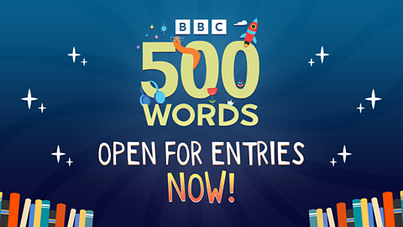

<https://www.bbc.co.uk/teach/500-words>

**500 Words is finally open for entries, it's time to get writing!**[**Submit your stories here**](https://www.bbc.co.uk/500wordscompetition/submissions-fe/index.html#/profile)**before 9pm on Friday 8 November 2024.**

There are two age categories: **5-7 and 8-11 year-olds**. All children need to do is write a story they would love to read in 500 Words or less.

We would love children of all abilities to enter; **spelling, punctuation and grammar** are not marked - it's all about creativity!

50 finalists will be invited to go to a glamorous [**grand final**](https://www.bbc.co.uk/teach/500-words/articles/zfwdtcw) at Buckingham Palace in February next year, where the bronze, silver and gold winners in each category will have their stories read out by celebrities.

There are also lots of [**prizes to be won**](https://www.bbc.co.uk/teach/500-words/articles/zctk7v4#zytbqyc) - each winner will take home a bundle of books and the gold winners also win 500 books for their school library.

Not only that, the winning stories will receive an original [**illustration**](https://www.bbc.co.uk/teach/500-words/articles/zqbh46f) from **Dapo Adeola, Nigel Parkinson, Lydia Monks, Momoko Abe, Rob Biddulph or Yasmeen Ismail.**

It's incredibly important to us that children of all abilities and backgrounds are able to take part in the competition; therefore each school that enters a story and receives 50% free school meals or more, is entitled to a £50 National Book Token and three £10 book tokens for their pupils.