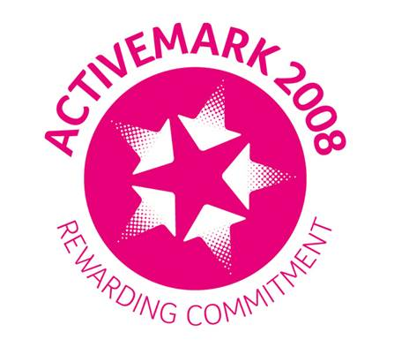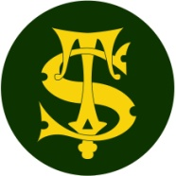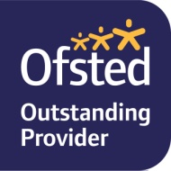

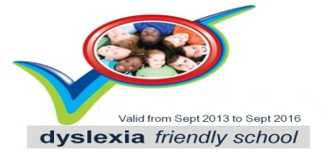**Investors in People Logo**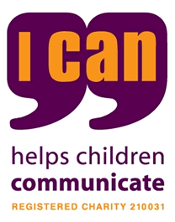 4th January 2021

Dear Parents/Carers,

We are sure you are aware of the debate and confusion this weekend around the re-opening of primary schools in England. The government still believe that it is safe to open the majority of schools including those now in Tier 4 except in areas with the very highest infection rates such as London. Teaching unions disagree due to the increase in transmission and infection rates currently recorded across England. After very careful consideration and consultation with school staff and governors we have to inform you of the following:

* Unfortunately, due to staffing issues four classes will NOT re-open tomorrow. These are Year 5R (Miss Robinson’s class), Year 4P (Miss Platt’s class), Year 1S (Miss Sale’s class) and Nursery P ( Miss Partington’s class). Remote learning will be organised for children in NP, 1S, 4P and 5R not attending school, via the school google classrooms starting at 9am Tuesday 5th January. Children at home will be covering the same curriculum as children in school. If your child is currently on Free School Meals and you wish to collect a packed lunch from school, please inform the office.
* ALL OTHER CLASSES WILL BE OPEN AS NORMAL THIS WEEK.
* Breakfast or Aftercare facilities will be open this week as normal.
* Can I strongly suggest that parents send their children into school warmly dressed as teachers will need to keep some doors and/or windows open throughout the day to help limit the spread of the virus.

These arrangements will be reviewed weekly or sooner if Government guidance changes.

We are extremely sorry for the short notice and appreciate how difficult this will be for some families, especially arranging childcare.

At this time of high rates of infection across the country, can we please remind you of the safety measures we have in place to keep our school community safe; sticking to the staggered start/finish times for children in school, **wearing face masks** and socially distancing in the playground and adhering to the tier 4 restrictions when outside school.

Yours Sincerely,

David Deane (OBE)

Headteacher