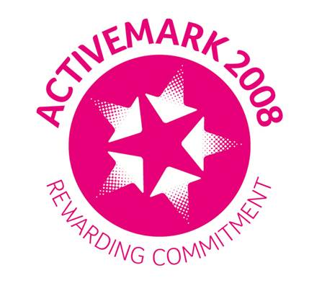

**Investors in People Logo**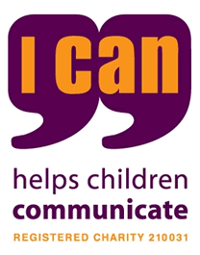  Thursday 21st May 2020

Dear parents and carers,

School leaders aim to re - open our school on Monday 8th June 2020 for all children in Nursery, Reception, Year 1 and Year 6. The children of key workers in Years 2, Year 3, Year 4 and Year 5 are also allowed to come to school from this date.

We want to make the re-opening as safe as we possibly can for all children, staff and their families at home. School leaders are currently undertaking a detailed risk assessment to minimise the chances of anyone becoming sick or spreading the virus within school or the wider community.

Below is a very brief outline of the safety measures we will be taking in school to prevent the spread of infection:

* Children will be educated in small groups or “bubbles” with a maximum size of 15 children in each bubble. The children in each bubble will stay together all day, every day – whilst learning, eating lunch and at playtimes – to limit the spread of the virus.
* Children in each group/bubble will use the same classroom, the same resources and be taught by the same 3 adults (a teacher and 2 TAs) every day – to limit the spread of the virus. However this may not be the child’s class teacher and may not be in the regular classroom.
* Social distancing within classrooms will be organised with desks 2 metres apart. For younger children in the Early Years this will be more of a challenge but staff will encourage children to remain apart and explain why this is important now.
* **The single most important measure we will take is to do everything possible to make sure that pupils within one bubble/group do not mix with other pupils from another bubble. THIS IS ESSENTIAL TO LIMIT THE SPREAD OF THE VIRUS.**
* Therefore playtimes and lunchtimes will be staggered and the playground itself separated into zones so bubbles don’t mix
* Most pupils will eat lunch in their classrooms to avoid any mixing of groups/bubbles
* There will be a one –way system in use within school so pupils do not mix with other groups.
* A staggered start and end to the day to avoid pupils and adults mixing
* Regular, supervised handwashing and hand sanitiser - 6 times per day – on entry to school, before and after playtime, before and after lunch, and before leaving school.
* Enhanced cleaning procedures within each class on all hard surfaces and around school on frequently touched surfaces like door handles etc

Above are just a very brief summary of safety measures we will be undertaking. There are many other safety measures too numerous to mention here to keep all pupils and staff safe.

**Parents can help by:**

Parents can help by dropping off and picking up their children promptly at the new staggered times set out below;

|  |  |  |  |  |  |  |
| --- | --- | --- | --- | --- | --- | --- |
|  | Year 6 | Year 1 | Key Worker pupils in Y2/3/4/5 | Acorn classroom pupils | Reception | Nursery |
| New drop off time | 8.30am | 8.45am | From 8.45am | From 8.45am | 9am | 9.15am |
| New pick up time | 2.45pm | 3pm | 3.15pm | 3.15pm | 3.15pm | 3.15pm onwards |

* Parents should enter the alleyway from either Dudley Street or St James Road, hand children over to staff immediately and leave via the pedestrian gate at the bottom of the staff car park. Please do not linger to talk to staff or other parents or congregate in groups.
* Please do not send your child into school if they are sick. The main symptoms of coronavirus are a new, continuous cough, a high temperature or a change to the senses of smell and taste; however, other symptoms include vomiting/diarrhoea and generally feeling unwell. It is important that if your child (or someone living in your household) has any of the symptoms identified, that you DO NOT send your child into school. If your child has a temperature and you have given them medicine for this, you must still keep them at home. The medicine will temporarily mask a raised temperature, but they may still have the virus.
* School undertook a survey of parents to find out roughly how many parents from Nursery, Reception, Year 1 and Year 6 intended to send their children to school from Monday 8th June. If you have said no and later change your mind and want your child to attend, please Email/phone the office and give 48 hours’ notice so we can “manage” the size of groups/bubbles.
* Please send children in clean school uniform every day – this will mean additional laundry

**Other key changes to note**

* There will be no breakfast club or after school club the first week back, although this will be reviewed
* There will be no toast for children in the mornings so please don’t send in any money. Children can bring a piece of fruit instead
* There will be no external visitors – no hymns, no music tuition, no sports coaches etc
* All queries and questions should wherever possible be managed by phoning the office or emailing school
* Only one parent will be allowed into the school reception/security lobby at a time and a queue system (2 metres) apart outside to be observed similar to supermarkets
* Any child who becomes ill will be immediately isolated within school and parents asked to collect them immediately

**Those pupils not attending school :**

Pupils in Year 2, Year 3, Year 4 and Year 5 will not be returning to school on 8th June unless they are key worker children. It is as yet unclear when they will return. Some parents of pupils in Nursery, Reception, Year 1 and Year 6 may choose to not send their children into school. This is your decision and your right ( at this time as normal regulations have been suspended) and school will not seek to penalise parents for non- attendance and they will NOT face fines/prosecution at this time.

**School will continue to provide daily, on line learning for these pupils not attending until further notice.**

I do hope this letter sets out the school’s current position clearly and no doubt I will be in touch again in the near future with another update.

If you have questions or queries please use the school email address:

[stthomasofcanterbury.rcprimaryschool@salford.gov.uk](mailto:stthomasofcanterbury.rcprimaryschool@salford.gov.uk)

God bless,

Mr Deane OBE

Head teacher