

**Geography Knowledge Organiser**

**Year 5**

The Amazon Basin

Summary Statement

Children will explore this resource-rich environment, investigating the impact of human activity on the natural resources and communities of the region. Use mathematical measures and analysis to create a poster on land use, cultural vulnerabilities, environmental impact and economic trade, for presentation at a class Earth summit.

|  |  |
| --- | --- |
| **Key Vocabulary** | |
| **Spelling** | **Definition** |
| drainage basin | When a river collects water from many other rivers and settles at the lowest point. |
| Amazon Basin | Part of [South America](https://en.wikipedia.org/wiki/South_America) drained by the [Amazon River](https://en.wikipedia.org/wiki/Amazon_River) and its tributaries |
| tributary | a river or stream flowing into a larger river or lake |
| tropical rainforest | A woodland area with only two seasons |
| Tropics | Hot regions between two latitudes |
| indigenous people | The first **people** who lived in any region, who sometime have to fight for their own lands. |

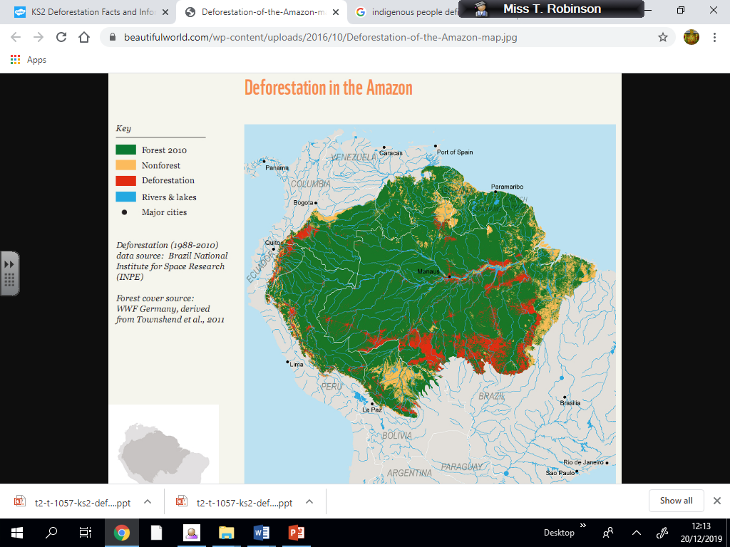

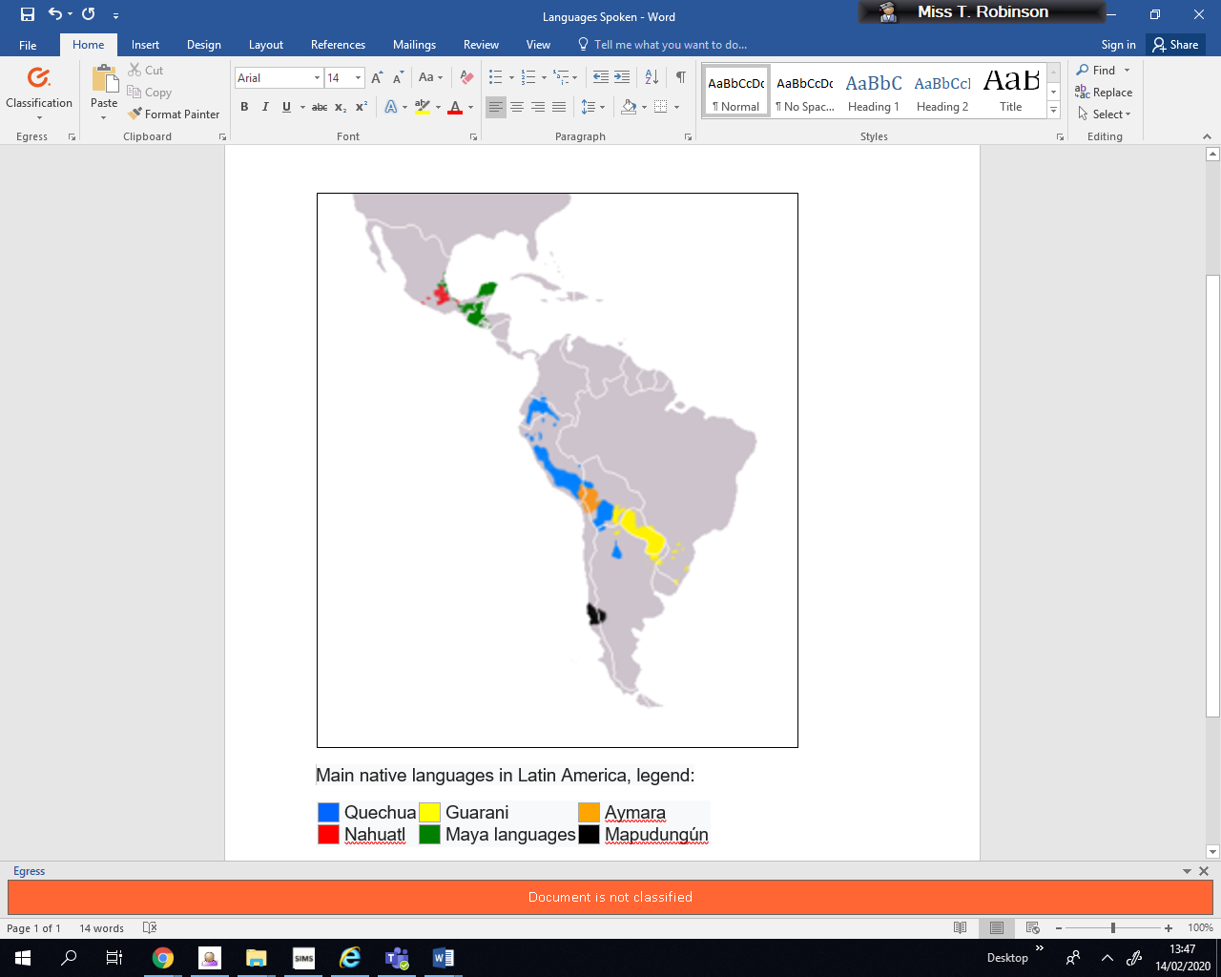

**By the end of the unit, children will know:**

* identify the River Amazon and surrounding rainforest on a map
* define a drainage basin
* discuss the environmental impact of Tropical rainforests on humans
* label a map with the tropics of Cancer and Capricorn
* compare the climate data of two cities in South America
* discuss the languages spoken by those living in the Amazon Basin
* discuss the threat to the lives of indigenous language due to industrial exploitation and forest fires
* define deforestation, discuss the reasons for deforestation, the effects of deforestation
* suggest some solutions to counter the effects of deforestation