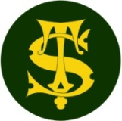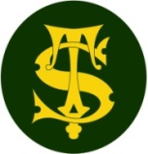

**History Knowledge Organiser**

**Year 5**

The Americas

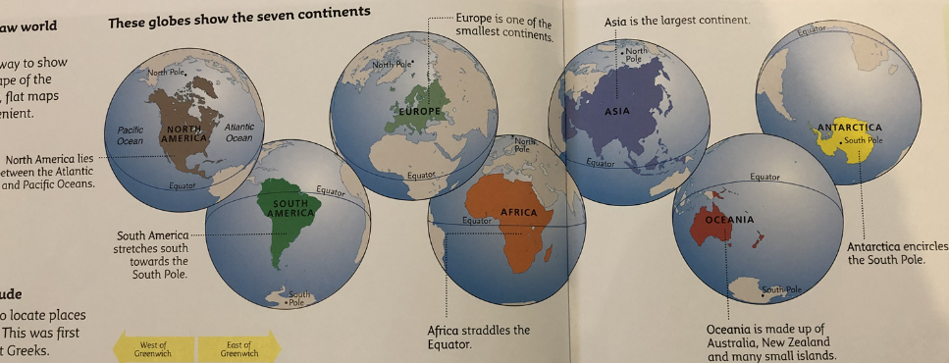

Summary Statement

Children will learn about continents and the environments of North America.

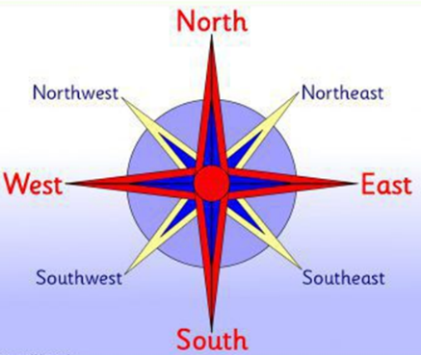

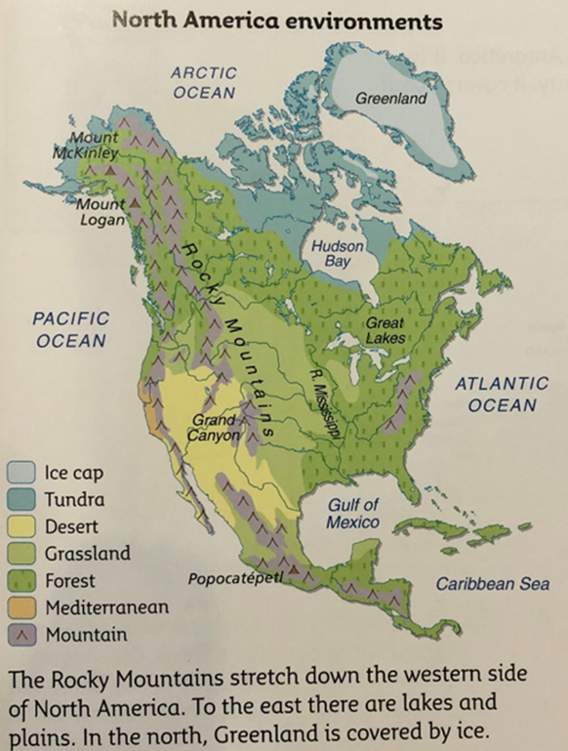

**By the end of the unit children will know:**

**Locate the seven continents and name them.**

**Using maps we could find some of the world’s countries and label four major cities in North America. Also the 23 countries.**

**Learned the 8points of a compass.**

**We can use maps, atlas and globes to locate countries and describe some of their features.**

**We have looked at a political map of South America and could identify some countries of famous South American footballers.**

**We understand the differences between physical boundaries and political boundaries.**

|  |  |
| --- | --- |
| **Key Vocabulary** | |
| **Spelling** | **Definition** |
| continent | A large area of land together with many nearby islands |
| compass | An instrument to show direction. |
| polical map | It names all the countries and shows their borders. |
| tundra | A type of biome that is a vast, flat, treeless Arctic area of North America. |
| biomes | A large natural area of flora and fauna-a major habitat.e.g.forest or tundra |

