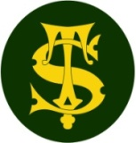

Geography Knowledge Organiser
Year 3
Biomes of the World

Summary Statement: Children will use maps, atlases, globes and digital mapping to locate countries and describe features studied and understand key aspects of physical geography, including: climate zones, biomes and vegetation belts.

Key Vocabulary
Spelling | Definition
Equator | A line that circles the Earth, separating it into the Northern and Southern Hemispheres. It is also the point on Earth that is always the closest to the sun.
Tropics | The region of Earth that is near to the equator.
Climate | The average measurements of temperature and weather over a period of time.
North Pole | The most northern point of the Earth.
South Pole | The most southern point of the Earth.
Natural Environment | It encompasses all living and non-living things that occur naturally on Earth.
Aquatic | A biome that is formed almost entirely by water and depends on water for life to grow.
Temperate Deciduous Forest | A biome that has many deciduous trees, which drop their leave in Autumn. They are also known as broad-leaf forests because the trees have wide, flat leaves.
Boreal/Taiga Forest | A large community of plant and animal life, living in a major natural habitat, such as a forest or lake.
Tundra | The coldest of biomes and a mainly treeless plain, where harsh conditions make it hard for plants and animals to survive.
By the end of the unit, children will be able to:

- Locate Chembakoli and understand its climate.
- Understand biomes and locate the position of biomes across the world.
- Understand which animals live in each biome.
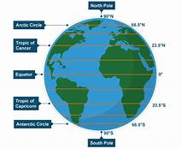
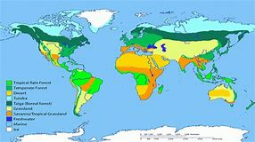
India
