**Geography Knowledge Organiser**

**Year 2**

The United Kingdom

Summary Statement

Children will learn about the United Kingdom; its four countries and their capitals.

|  |  |
| --- | --- |
| **Key Vocabulary** | |
| **Spelling** | **Definition** |
| United Kingdom | Made up of 4 counties – England, Scotland, Wales and Northern Ireland |
| Capital City | The main city where the government is located. It is usually the biggest city in the country. |
| City | A large human settlement. They often have a cathedral. |
| Landmark | Something that is used to recognise a place. E.g. A landmark in London is Big Ben. |
| Coastline | Where land meets the sea or ocean. |
| Landscape | An area of land with observable features. |
| Observable features | Something that is noticeable e.g. mountains and rivers. |
| Sea | A particular area of water within the ocean. |
| Continents | A great block of land together with any nearby islands. |
| Ocean | A very large expanse of sea. |

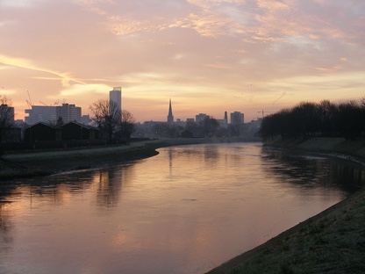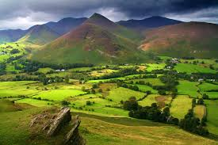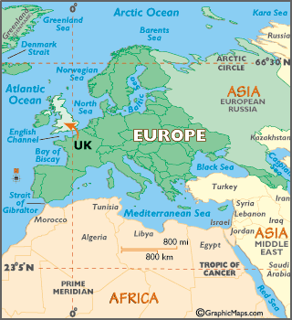

**UK’s 4 Countries and their capital cities**

England – London

Wales – Cardiff

Scotland – Edinburgh

Northern Ireland - Belfast

**By the end of the unit, children will be able to:**

* **Know the names and locations of the four countries of the UK.**
* **Name landmarks linked to the capital cities of each of the four countries**
* **Be able to name and locate some of England’s largest cities.**
* **Identify that the UK is an island and name the main seas around it.**
* **Group landscapes based on observable features.**
* **Use an atlas to identify where certain places are in the UK.**