
PARK RISK ASSESSMENT DATE RISK ASSESSMENT PREPARED: 13th March 2016
ACTVITY: |  | Design and Technology
VENUE : STOC
RISK ASSESSMNET OF: Stitch unpicker

LOCTION OF ACTIVITY: CLASSROOMS. Only to be used by competent pupils (KS2).

HAZARDS | CONTROL MEASURES |  | ADDITIONAL INFORMATION
Point and blade of a stitch unpicker | - Avoid injury by choosing tools appropriate to task and appropriate to the age and experience of the user.  - Children who are likely to cause injury to themselves or others are prohibited from a stitch unpicker.  - All activities using stitch unpicker to be supervised.  - Always keep the blade covered when you’re not using it. |  | - Also known as a seam ripper (or a quick unpick, or just an unpicker), this sewing tool is small and unsuspecting – yet it can also cause havoc with your project.  - The quality of your seam ripper will determine how long the blade remains sharp. As soon as it starts to feel dull (as in, it feels harder to easily rip through fabric), throw it away and use another. Not only is it easier to ruin fabric with a blunt blade, you’re more likely to stab yourself.
 | How to use a stitch unpicker  - Unbunch any fabric around the area you’re going to unpick.  - Position the fabric so you are going to be unpicking away from you  - Always try to push toward the least valuable fabric (such as a hem) as an extra safeguard.  - Unpick from the outside of the fabric.Working on one side of the fabric, slide the longest prong underneath the stitch you’re going to unpick (so the shorter prong is facing up), and gently push forward, minding the sharp point as you do. |  | Children and staff to be read the risk assessment before using the Stitch unpicker.  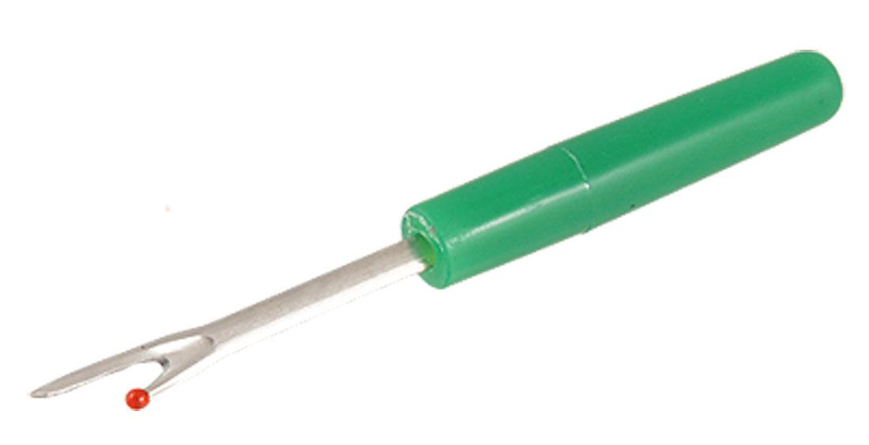

RISK ASSESSMENT PREPARED BY: Tracy Robinson
NAME OF SCHOOL: St. Thomas of Canterbury RC Primary

