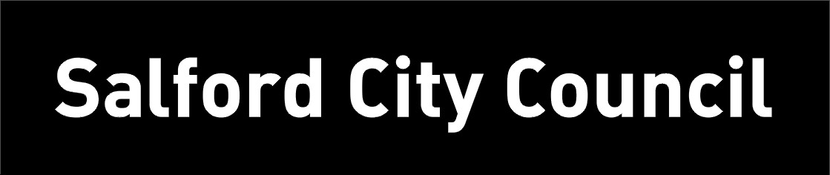
PARK RISK ASSESSMENT DATE RISK ASSESSMENT PREPARED: 13th March 2016
ACTVITY: |  | Design and Technology
VENUE : STOC
RISK ASSESSMNET OF: Pliers

LOCTION OF ACTIVITY: CLASSROOMS

HAZARDS | CONTROL MEASURES |  | ADDITIONAL INFORMATION
Pliers | - Avoid injury by choosing tools appropriate to task and appropriate to the age and experience of the user.  - Children to be made aware that the blades could cause a pinching cut.  - Children who are likely to cause injury to themselves or others are prohibited from using pliers.  - Wear safety glasses or goggles, or a face shield (with safety glasses or goggles) whenever there is a potential hazard from flying particles, pieces of wire, etc.  - Cut at right angles. Never rock the cutting tool from side to side or bend wire back and forth against the cutting edges.  - Pull on the pliers; do not push away from you when applying pressure. If the tool slips unexpectedly, you may lose your balance or hit your hand against equipment or something else hard that could result in an injury. |  | - Pliers are made in various shapes and sizes and for many uses. Some are used for gripping something round like a pipe or rod, some are used for twisting wires, and others are designed to be used for a combination of tasks including cutting wire.
Children and staff to be read the risk assessment before using the pliers.

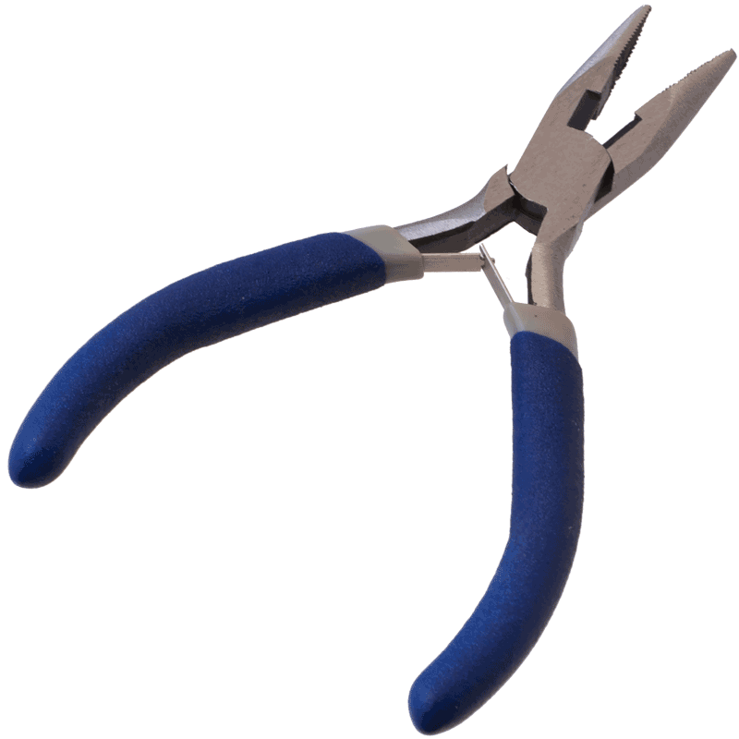

RISK ASSESSMENT PREPARED BY: Tracy Robinson
NAME OF SCHOOL: St. Thomas of Canterbury RC Primary

