
PARK RISK ASSESSMENT DATE RISK ASSESSMENT PREPARED: 13th March 2016
ACTVITY: |  | Design and Technology
VENUE : STOC
RISK ASSESSMNET OF: Hand operated drill

LOCTION OF ACTIVITY: CLASSROOMS- to be used with 1:1 adult supervision.

HAZARDS | CONTROL MEASURES |  | ADDITIONAL INFORMATION
Drill bits | - Give appropriate instructions for the use of the hand drill to inexperienced users.  - Always use a vice or bench hook and clamp to secure the material that you will be drilling into.  - Inexperienced users may lack the physical strength to hold it securely and some form of clamping will be required. If the work is too large to fit into a suitable vice hold it as securely as possible, perhaps with the aid of G clamps.  - Warn students about the hazards of sharp edges of materials. Gloves may be appropriate in some cases.  - Eye protection should be warn if there is a risk of debris being expelled towards the eye.  - Long hair and loose clothes should be tied back to reduce the risk of entanglement in the drill. |  | - Regularly check wooden handles for tightness, and for splits, and replace when necessary. Plastic handles are usually more robust and are less likely to work loose. Students should be instructed to seek assistance from a teacher should they find that a handle is loose.  - Children and staff should be made familiar with the risk assessment before using the hand operated drill.
 |  |  | 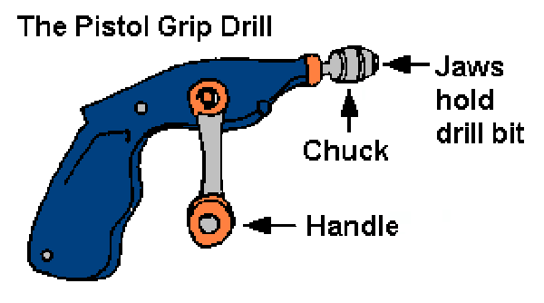

RISK ASSESSMENT PREPARED BY: Tracy Robinson
NAME OF SCHOOL: St. Thomas of Canterbury RC Primary

